TSL Tutor Project Scheme

**© Anar Kazimov and Software Gates Team, 2016**

This document contains information about the structure of the TSL and aims to create a smooth transition to the project.

Before talking about our structure we need to define the main functions of the app.

# Main Functions

1. Detection of the preferable language.

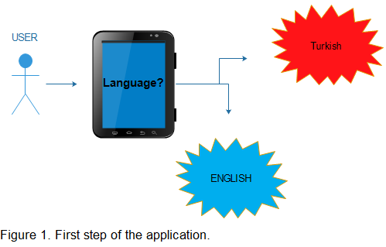

1. When user will use our app for a first time we will ask his name and we will show it in the Turkish Sign Language. Signs will be shown consequently using JavaScript.

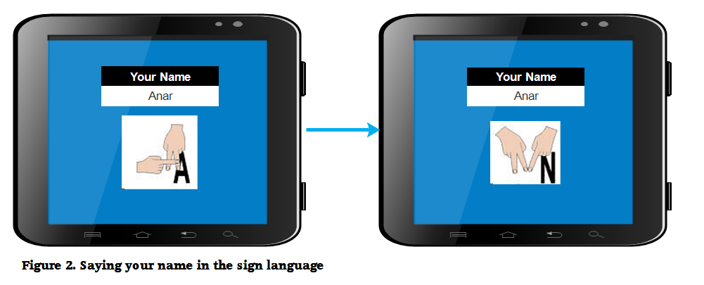

1. From now on user will see this page when will entering the app. (By this we mean that he won’t be asked his name or language, as for UI it had to be the same one in the previous images but for convenience we didn’t add it. TSL will be replaced TID in the Turkish branch of the app)

